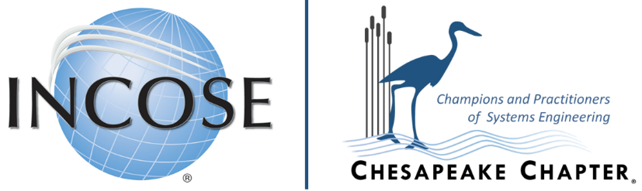

Chesapeake Chapter Science, Technology, Engineering and Mathematics (STEM) Scholarships Application

Scholarship 1: Chesapeake Chapter Members or Family Members $2,500

Scholarship 2: Open Scholarship $1,500

Award is payable directly to the student.

Purpose: The INCOSE Chesapeake Chapter seeks to award merit-based scholarships to undergraduate and/or graduate level students for commitment to the engineering field of study and to aid them in accomplishing their career goals.

For 2022 there are two INCOSE Chesapeake Chapter scholarships available
- The Chesapeake Chapter or Family member scholarship is available to members of the Chesapeake Chapter or family members of the Chesapeake Chapter member that meet the criteria as outlined below.
- The Open Scholarship is available to all applicants that meet the criteria as outlined below.

Criteria: Applicant must:
- Be an academically competitive, well-rounded, college student.
- Be pursuing a science or engineering field of study (i.e., engineering, math, computers, cyber, or IT any major that addresses electrical engineering, computer engineering, computer science, information technology, cyber, mathematics, physics, aerospace engineering, mechanical engineering – and can apply their studies directly to Systems Engineering.
- Have a cumulative GPA of at least 3.0 on a 4.0 scale. Special performance can lead to consideration in cases of lesser GPA.
- All Merit scholarships are STEM based.

Please note: Students who anticipate a degree in other science, like pre-med, pre-law, biology, environmental, or any form of engineering that does not address/support systems engineering, are not likely to receive this scholarship.
Applications deadline is October 15, 2022.
Submit to: scholarship@incose-cc.org
(Please submit questions, at the submission email address above)

INCOSE Chesapeake Chapter Scholarship Submission
ALL APPLICATIONS MUST BE SUBMITTED ONLINE by October 15,2022
Submit to scholarship@incose-cc.org

There are four (4) parts to the INCOSE Chesapeake Chapter scholarship submission

- General Information
Student Name (First, MI, Last)
Scholarship | Member/Family Member $2,500 |  |  |  | Open Scholarship $1,500
Home Address
(Street Address, City, State Zip)
Phone Number(s) | Mobile
 | Home
Email Address
School
Major
Credits Earned
Overall Cumulative GPA
Anticipated Graduation Date
US Citizen ?
MD Resident ?
(Member/Family Member scholarship only)  INCOSE Chesapeake Chapter Membership |  | INCOSE Member ID
 |  | (If Family member name and Member ID below)
 |  | Family Member Name
 |  | INCOSE Member ID

- Essay
The Scholarship essay submission consists of four (4) parts
  - In 300 words or less, provide a Personal Statement describing your technical and interpersonal skills
  - In 100 words or less, explain in your own words, how would you define systems engineering and why systems engineering is important to a project?
  - In 200 words or less, describe your participation in a systems engineering related project. Describe where you used systems engineering to complete the task or how systems engineering principles could have provided a better result. It does not have to be a technical or school related project, include hobbies, home projects, or a personal accomplishment, etc.
  - In 100 words or less, describe how you can apply systems engineering to your chosen career and how to apply systems engineering principles within your chosen career path to achieve better results.
- Resume
Provide a resume describing relevant course work, any engineering related projects, memberships in professional organizations, certifications, honors, awards, and work experience.
- Transcript
Provide an Unofficial Transcript for your current educational institution. If not currently enrolled, provide an unofficial transcript for most recent educational institution.

